Accessible Door Openers
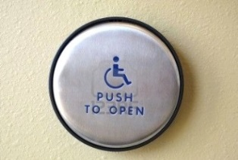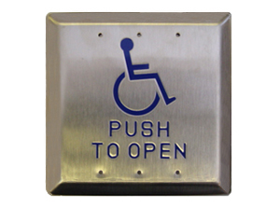
How to use them?
Correctly:
- Press the button in the center once
Incorrectly:
- Pressing the button on the edges
- Pressing the button multiple times
- Using force to push or pull the door during the period when its automated function is in progress
Continuous incorrect usage of the accessible door system can cause damage to the system making it unresponsive to any further user interaction.

